**CTSO Advisor Checklist**

[[<https://www.houstonisd.org/careerreadiness>](https://www.houstonisd.org/careerreadiness)](https://www.houstonisd.org/domain/52071)

⎕ **CTSO Commitment Form**

**Due Tuesday, September 13, 2022**

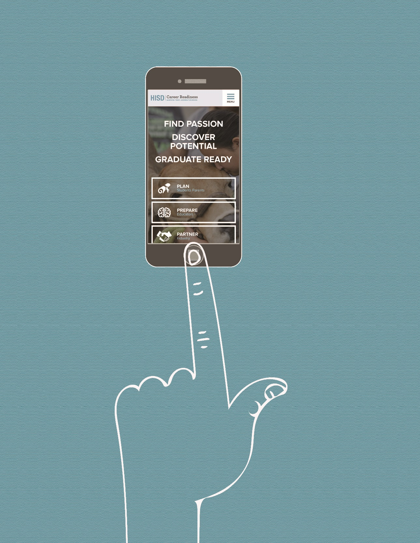 Name, Organization, Principal Signature

⎕ **Fall Portfolio**

**Due Wednesday, January 25th, 2023**

1. Chapter Documentation
2. Monthly Meeting Records
3. Community Service Project Documentation  
   One activity, BOTH fall and spring semester
4. Leadership Conference Documentation  
   Minimum one per school year, fall or spring semester
5. Fundraiser Documentation (Optional)
6. Financial Documentation (Optional)
7. Extra Duty Pay Reimbursement form

⎕ **Spring Portfolio**

**Due Monday, May 8, 2023**

1. Chapter Documentation
2. Monthly Meeting Records
3. Community Service Project Documentation  
   One activity, BOTH fall and spring semester
4. Leadership Conference Documentation  
   Minimum one per school year, if not included in Fall Portfolio
5. Fundraiser Documentation (Optional)   
   * Participate in When I Grow Up EXPO as a CTSO Fundraiser!
6. Financial Documentation
7. Extra Duty Pay Reimbursement form

**Documents on Website:**

**Commitment Form, Extra Duty Pay Form, Bulb Portfolio Video**

**Terms of Commitment**: A reimbursement form AND portfolio must be submitted in the fall semester if you are sponsoring a CTSO for the entire school year. **CTSO extra duty pay will be split into two separate payments; fall and spring.** We allocate funds for pay based on the fall reimbursement submissions. Thus, the budget will not have sufficient funds to cover your spring or full year reimbursement if we do not receive your reimbursement form by the fall due date.